CSE 5382: Secure Programming - Fall 2018 **Student Name**: Biswa Ranjan Nanda

Capture the Flag Bonus Exercise **Student ID**: 1001558251

# Flag Table

Place the flags once you find them in the appropriate table entries below. Each category has a maximum of 20 points with each higher level of difficulty granting an increasing number of points. Maximum score for all challenges completed is 100 points.

|  |  |  |  |  |  |
| --- | --- | --- | --- | --- | --- |
|  | **Cryptography** | **Malware** | **Network Capture** | **Reverse Engineering** | **Steganography** |
| **Level 1 (2 Points)** |  |  |  |  |  |
| **Level 2 (3 Points)** |  |  |  |  |  |
| **Level 3 (4 Points)** |  |  |  |  |  |
| **Level 4 (5 Points)** |  |  |  |  |  |
| **Level 5 (6 Points)** |  |  |  |  |  |

# Explanation of Approaches

Include descriptions along with screen shots of the approaches you took to solve these challenges.

## Cryptography

### Level 1 – Orange Julius

### flag{backoff_malware}

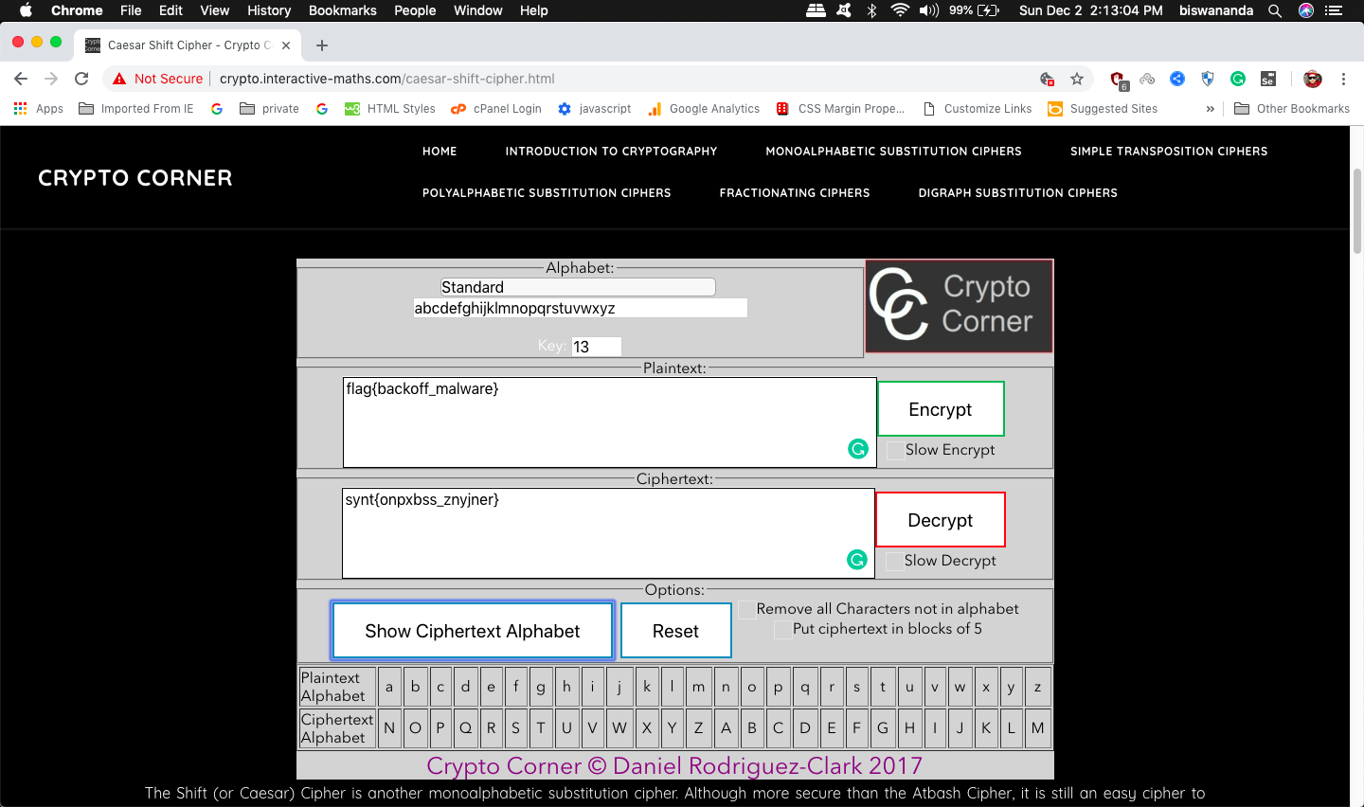

### Level 2 – Block Chain

### Level 3 – DASH DOT COM

### Level 4 – VIII A Small Example

### Level 5 – Big Blue Randu

## Malware

### Level 1

### Level 2

### Level 3

### Level 4

### Level 5

## Network Capture

### Level 1 – Modicon-FTP

### Level 2 – Modicon-HTTP

### Level 3 – WinXP-HAVEX

### Level 4 – MICROLOGIX56

### Level 5 – BACNET-COVERT

## Reverse Engineering

### Level 1 – Script Kiddie

### Level 2 – The PDF Your Parents Warned You About I

### Level 3 – Split Ends

### Level 4 – The PDF Your Parents Warned You About II

### Level 5 – Rock Scissors Paper Lizard Spock

## Steganography

### Level 1 – Moo Cow

### Level 2 – Milk Run

### Level 3 – Got Root

### Level 4 – AI EDM

### Level 5 – Final Frontier